

QSAR-Based Drug Repurposing and Ensemble Docking Validation Targeting SARS-CoV-2 NSP3 Mac1

Rama Al Assi 202208435 and Charbel Charbachi 202205318
Supervised by Dr. Joseph Rebehmed
BIF 599 - Capstone Project
May 2, 2026

Contents
Abstract 2
Introduction 3
Methodology 4
Machine Learning: 5
Ensemble Cross docking and Redocking: 8
Results and Discussion 13
Machine Learning: 13
Ensemble Cross docking and Redocking: 17
Limitations and Future Directions 21
Conclusion 22
References 23

Abstract
SARS-CoV-2 Macrodomain 1 (Mac1), a domain within non-structural protein 3, is involved in reversing ADP-ribosylation and helps the virus interfere with host antiviral responses. Because of this role, Mac1 has become an important target for antiviral drug discovery. In this study, we developed an integrated computational drug-repurposing workflow combining QSAR machine learning, structural analysis, and molecular docking to identify potential Mac1 inhibitor candidates.
Bioactivity data were collected from ChEMBL assay CHEMBL5441457 and curated through structure standardization, duplicate removal, activity filtering, and scaffold-aware splitting. Classification and regression QSAR models were trained using RDKit and Mordred descriptors, MACCS fingerprints, and Morgan fingerprints. The final classification model, a multi-space SVM-RBF, showed strong test-set performance, with MCC = 0.711, ROC-AUC = 0.928, and balanced accuracy = 0.869. The selected regression model, an SVR-RBF using the full feature set, had more use in ranking than exact potency prediction, achieving Spearman’s rₛ = 0.647 and pairwise accuracy = 0.740 on the test set.
The trained models were applied to 1,991 approved ChEMBL compounds. Elvitegravir and Trelagliptin were classified as predicted active candidates, while Linagliptin and Tafenoquine were kept as exploratory near-threshold hits. However, all prioritized candidates were excluded from the models’ applicability domains and should therefore be interpreted cautiously.
In parallel, ensemble docking validation was performed using the Mac1 receptor conformations 5SOP and 5SRY. The initial crystallographic ligand inventory contained 786 unique Mac1 ligands, giving 1,572 docking jobs when each ligand was docked against both receptor structures. Of these, 1,548 jobs were completed successfully, while 1,036 had readable crystallographic reference ligands that allowed RMSD evaluation. After excluding ligands classified as off-site binders, the final refined canonical active-site validation set contained 478 unique ligands. Across this refined set, the 5SOP/5SRY ensemble achieved a best-of-20 pose-recovery rate of 54.6% at 2.0 Å and 75.3% at 3.0 Å. These results support the usefulness of the two-receptor ensemble for pose generation, although Vina ranking remained limited. Overall, this workflow follows a structured computational approach for prioritizing possible Mac1 inhibitors, while emphasizing the need for docking follow-up and experimental validation.

Introduction
Severe acute respiratory syndrome coronavirus 2 (SARS-CoV-2), the pathogenic cause of Covid-19 is an important target for antiviral drug discovery due to its continuous evolution and the need for effective therapy rather than vaccinations. One of the viral proteins is non-structural protein 3 (NSP3), which plays an important role in host immune regulation. Macrodomain 1 (Mac1), an interesting domain of NSP3, binds and removes ADP-ribose modifications from proteins. This activity helps the virus interfere with host antiviral defense mechanisms, making Mac1 a promising target for antiviral drug development (Hoch, 2021).
However, Mac1 remains difficult to target because its binding pocket is highly polar and naturally adapted to bind ADP-ribose. Although fragment screening, crystallographic studies, and virtual screening have identified potential Mac1 binders, many reported compounds show weak potency or require further validation (Frick et al., 2020). Therefore, additional computational strategies are needed to identify stronger and more drug-like Mac1 inhibitor candidates.
QSAR Modeling and Machine Learning provide a useful tool for predicting drug activity based on chemical structure. By using molecular descriptors and fingerprints, machine learning models can learn structural patterns associated with biological activity. However, ligand-based QSAR alone does not explain how a compound may interact with the protein binding site. For this reason, docking analysis is an important complementary approach.
Therefore, we aim to develop an integrated computational drug repurposing pipeline targeting the SARS-CoV-2 NSP3 Mac1 domain. This study combines QSAR machine learning modeling and cross-docking analysis.

Methodology
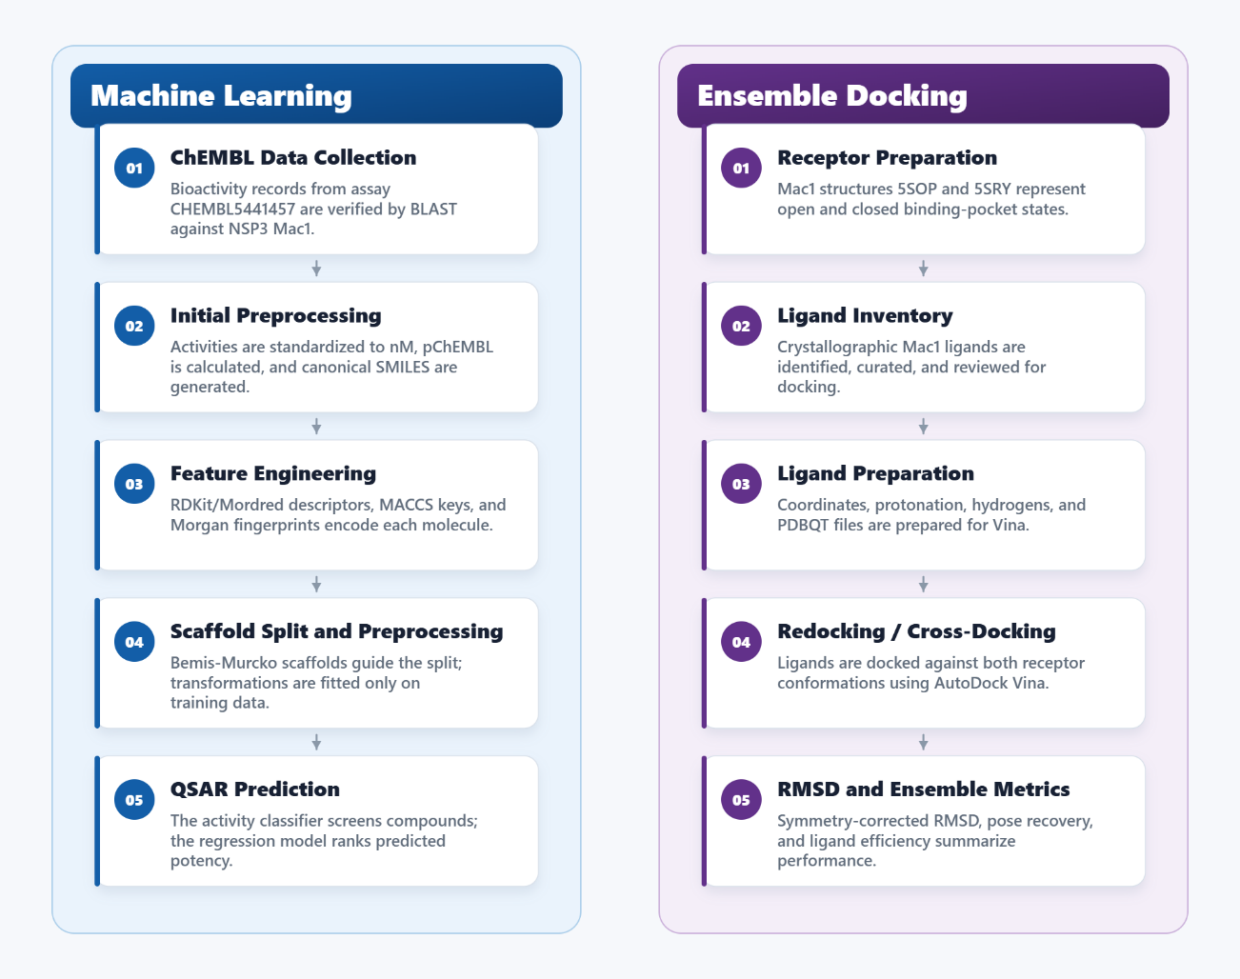
Study Overview:

Figure 1. Overview of the computational workflow for SARS-CoV-2 Mac1 drug repurposing. The pipeline integrates QSAR machine learning for candidate screening and ranking with ensemble docking validation using two Mac1 receptor conformations.
This study follows a computational pipeline combining QSAR machine learning and ensemble molecular docking to identify potential SARS-CoV-2 Mac1 inhibitors. Bioactivity data were collected, cleaned, standardized, molecular descriptors and fingerprints were generated, and split. Classification and regression models were then developed to screen and rank approved compounds based on predicted activity and potency. In parallel, two Mac1 receptor conformations were prepared for ensemble docking, crystallographic ligands were curated and used for redocking/cross-docking validation, and docking performance was evaluated.

Machine Learning:
Data Collection:
Bioactivity data were collected from the ChEMBL Database using the biochemical assay CHEMBL5441457. Initially, the Dataset contained 1,443 trials in addition to the target sequence. To make sure that these trials belong to NSP3 Mac1 of SARS-CoV-2, we aligned the sequence in the dataset to the reference target sequence taken from NIH using BLAST.
Initial Data Preprocessing and Feature Engineering:
The raw dataset was cleaned and standardized before feature generation. Rows with missing SMILES values were removed, and all standard activity values were then converted into a common unit, “nM”. Then, missing pChEMBL values were calculated from the activity values “IC50”, and molecular structures were standardized and converted to canonical SMILES using RDKit. Molecules that still lacked pChEMBL or failed canonicalization were removed.
Then, duplicate molecules were removed by keeping only the record with the highest pChEMBL value for each canonical SMILES. Finally, to ensure high-quality data is used, the cleaned dataset retains only rows with the standard relation “=” and R² ≥ 0.9.
For the classification dataset, molecules falling within a grey zone range of ±0.2 pChEMBL units around the activity threshold (5.8-6.2) were excluded. This step would reduce noise in the binary class assignments. The remaining molecules were then labeled as active (pChEMBL ≥ 6.0) or inactive (pChEMBL < 6.0).
After applying initial cleaning, molecular features were generated from the canonical smiles using RDKit and Mordred 2D descriptors, and MACCS (167 bits) and Morgan fingerprints (radius = 2 and 2,048 bits). Then, duplicate descriptor columns were removed, and infinite values were converted into missing values.
Scaffold Generation and Data Split:
Bemis–Murcko scaffolds were generated from the canonical SMILES using the RDKit, and a scaffold-aware split was applied. This step prevents data leakage and provides a more accurate evaluation (Guo et al., 2025). The datasets were split into 80% training and 20% testing data using a fixed random seed (42).
Leakage-Safe Preprocessing:
To avoid leakage, a second stage of preprocessing was applied to both models’ datasets after the split. Descriptor-based features and fingerprint-based features were treated separately. Features including RDKit and Mordred descriptors with more than 20% missing values were eliminated, and the remaining missing values were imputed using the median values calculated from the training set. Constant descriptors and highly correlated descriptors with a correlation ≥ 0.95 were then removed using the training sets, and then, the features were standardized and fitted only on the training data. While for MACCS and Morgan fingerprints, missing values were filled with 0, and the features were kept as binary 0/1 values. Only Constant fingerprint bits were removed using a variance filter applied on the training set. And finally, the same transformations were applied to the test set. These stepes ensures that no information from the test set is used in modeling.
Model Development:
Two QSAR modeling tasks were developed using processed datasets: (i) The activity classification model; distinguishes active from inactive compounds. And (ii) The regression ranking model; prioritizes compounds according to their predicted pChEMBL values.
For both modeling tasks, multiple molecular representation spaces were evaluated, including molecular descriptor features, MACCS fingerprints, Morgan fingerprints, combined fingerprints, and the full feature set containing both descriptors and fingerprints. And several machine-learning algorithms were evaluated for each task. For activity classification, Logistic Regression, RBF-kernel Support Vector Machine, Random Forest, and XGBoost were tested. For regression-based ranking, ElasticNet, Partial Least Squares regression, RBF-kernel Support Vector Regression, Random Forest, and XGBoost were evaluated.
For classification purposes, A multi-space representation pipeline was also tested. By selecting the most informative features from descriptors, MACCS fingerprints, and Morgan fingerprints independently and then combining them into a reduced feature set. This enabled the classifier to benefit from a combination of different molecular information, while minimizing redundancy and dimensionality, as frequently done in QSAR (Orosz et al., 2022; Li et al., 2021).
Hyperparameter tuning was performed using randomized search, where different hyperparameter combinations were evaluated using 5-fold scaffold-based cross-validation.
Two dimensionality-reduction strategies were used for RDKit and Mordred descriptors: (1) SelectKBest (retain the top-k most discriminative features) and (2) Principal Component Analysis (PCA) (with the number of components regarded as a hyperparameter). For fingerprints dimensionality reduction, we used SelectKBest to select the most informative bits. We did not apply PCA for fingerprints, as it is not ideal for binary data (Song et al., 2019).
Since active compounds are often underrepresented in QSAR screening datasets, a relaxed activity-probability threshold of 0.24 was used instead of a stricter threshold (0.34). to reduce the risk of missing potentially active compounds (Esposito et al., 2021; Zakharov et al., 2014).
The applicability domain of each model was assessed using a k-nearest neighbor (k-NN) distance approach, where k = 5. For each training compound, the mean Euclidean distance to its 5 nearest neighbors was computed, and the 95th percentile of these distances was used as the domain threshold.
Model Evaluation:
Different metrics were utilized for model selection based on the objective. Matthews Correlation Coefficient (MCC) served as the primary metric for model selection in classification, and Spearman's rank correlation (rs) was employed for regression. Model selection was primarily determined by cross-validation performance rather than only by test-set performance. The selected model was compared to the model having the lowest train-CV performance difference to validate that the highest CV performance is not associated with increased overfitting risk.
Application of the Trained Models to the Prediction Dataset:
The selected classification and regression models were applied to an external prediction dataset containing approved ChEMBL compounds. Before prediction, the same molecular features used for training were generated for the prediction set.
The activity classifier was applied first as the primary screening step to identify predicted active compounds. Compounds with predicted activity probabilities above the relaxed classification threshold (0.24) were classified as actives. In addition, compounds with probabilities slightly below the threshold were retained as exploratory candidates because they were close to the decision boundary. Then, the regression model was used to assign them a ranking score, where higher scores indicated higher predicted potency.

Ensemble Cross docking and Redocking:
Ensemble Construction and Receptor Preparation:
Two crystal structures of the SARS-CoV-2 NSP3 macrodomain Mac1 were used for ensemble docking: 5SOP (open state) and 5SRY (closed state) as Mac1 structures with co-crystallized ligands RYI and RIW, respectively. These structures were selected to account for flexibility in the Mac1 ADP-ribose binding pocket, especially around loop residues 127–136 (Gahbauer et al., 2023).
The receptor structures were downloaded from the RCSB Protein Data Bank in mmCIF format and processed using Gemmi in Python (Berman et al., 2000; Wojdyr, 2022). For each receptor, one Mac1 polymer chain was retained, while water molecules, non-polymers, and crystallization additives were removed. Alternate conformations were resolved by retaining altloc A when present, otherwise the first available alternate conformer was retained. The native co-crystallized ligand was extracted separately and used for docking-box construction and RMSD evaluation. Receptors were converted to PDBQT format using mk_prepare_receptor.py from Meeko (Eberhardt et al., 2021).
Docking boxes were defined using the coordinates of each receptor’s native ligand. The initial search box was centered on the canonical Mac1 binding pocket with 8 Å padding in each direction and a minimum edge length of 18 Å, to cover the native ligand and surrounding Mac1 ADP-Ribose pocket while limiting searching space. If docking failed, a rescue second attempt was performed using an expanded box with 14 Å padding and a minimum edge length of 24 Å.

Ligand Inventory and Curation:
Crystallographic Mac1 ligands were collected using RCSB sequence-similarity search. Polymer entity 1 of the reference Mac1 structure 6W02 was used as the query, with an 80% sequence-identity threshold, a sequence-length range of 150–190 residues, and SARS-CoV-2 source-organism annotation to exclude unrelated proteins.
For each matched structure, the mmCIF file was downloaded and analysed with Gemmi. Entry-level information, including resolution, experimental method, deposition and release dates, sequence length, organism, and Mac1 chain identifiers, was extracted. Non-polymer ligands were identified from the _pdbx_nonpoly_scheme table in each mmCIF file. Their component identifiers, names, and molecular information were then taken from the chemical-component table (Westbrook et al., 2014). Only ligands assigned to Mac1 author chains were retained for curation.
Ligand curation was performed automatically and manually reviewed. Crystallization additives such as water, ions, salts, polyethylene glycols, solvents, cryoprotectants, buffers, simple acids, and reducing agents were excluded.
When the same ligand appeared in multiple structures, one representative source entry was selected for each unique component identifier. Selection prioritized higher crystallographic resolution, larger ligand-instance count, and more recent release date. If entries remained equivalent, the PDB identifier was used for final ordering.
Ligand Preparation:
Ligands were prepared from their crystallographic coordinates whenever possible, to preserve the experimentally observed binding pose. Ligand residues were extracted from their corresponding mmCIF files using Gemmi, based on the ligand chain identifier and residue position recorded in the structure file. For ligands with alternate conformations, conformer A was selected when present; if absent, the next available conformer was selected. The extracted ligand coordinates were saved in PDB format and then converted to SDF using Open Babel (O’Boyle et al., 2011).
Protonation was performed at pH 7.4 using Open Babel. When protonation failed or generated an unusable output, the original SDF file was retained, and the protonation status was recorded. Explicit hydrogens were then added using RDKit. If the ligand lacked 3D coordinates, ETKDGv3 conformer generation was applied (Landrum, 2016; Riniker and Landrum, 2015).
The final ligand PDBQT files were generated using Meeko’s mk_prepare_ligand.py.
For ligands that could not be prepared directly from the crystallographic structure, the corresponding Chemical Component Dictionary entry was used instead. These CCD-derived ligands were converted to SDF and processed using the same protonation, hydrogen-addition, and PDBQT preparation steps.
After PDBQT generation, each ligand was checked for the Meeko macrocycle pseudoatom types G0 and CG0, which are not supported by all versions of AutoDock Vina. Ligands containing these pseudoatoms were excluded before docking for prevention. To keep the comparison between receptors consistent, each unique ligand was prepared only once and stored in a shared cache. The same prepared ligand file was then used for docking against both 5SOP and 5SRY.
Redocking and Cross-Docking Protocol:
Docking was performed using AutoDock Vina with an exhaustiveness value of 16 and a maximum of 20 poses per docking job (Trott & Olson, 2010; Eberhardt et al., 2021). Each curated ligand was docked against both receptor conformations, 5SOP and 5SRY.
Docking jobs were classified as self-redocking when the ligand originated from the same PDB entry as the receptor conformation used for docking, and as cross-docking otherwise. Cross-docking was used as the more robust validation condition because it tested whether each receptor conformation could accommodate ligands crystallized in different Mac1 structural contexts.
All docking boxes were centered on the receptor’s native ligand and targeted the canonical ADP-ribose binding pocket. Docking was performed in serial CPU mode using AutoDock Vina. If no valid pose was generated, docking was repeated using the expanded search box. Docked PDBQT outputs were then converted to SDF using Meeko’s mk_export.py.
RMSD Evaluation:
Docking performance was evaluated by comparing the predicted ligand poses with their crystallographic reference poses using symmetry-corrected heavy-atom RMSD. The poses were assessed directly in the receptor binding site, without any additional alignment after docking. For cross-docking cases, the source receptor was first aligned to 5SRY and 5SOP using Cα-based least-squares superposition with the Kabsch algorithm (Kabsch, 1976). This placed the reference ligand and the predicted docking pose within the same coordinate frame, allowing a direct comparison between them. Cα atoms were matched by residue identity whenever possible; when residue matching was insufficient, Cα atoms were matched according to their order along the protein chain. Jobs with receptor-alignment RMSD greater than 3.5 Å were excluded as structural mismatches.
After receptor alignment, the crystallographic reference ligand was placed into the docking receptor coordinate frame. RDKit was then used to calculate symmetry-aware heavy-atom RMSD for each docked pose. Symmetry correction was used to account for equivalent atoms in groups such as phenyl rings, carboxylates, and phosphates. The docked poses were assessed in their predicted binding positions, without applying any additional ligand alignment after docking.
Pose recovery was assessed using established RMSD thresholds (Warren et al., 2006). A docking job was considered successful when the lowest RMSD among the top-1, top-3, top-5, or best-of-20 poses was ≤ 2.0 Å. A secondary threshold of ≤ 3.0 Å was also reported to capture near-native poses. Scoring quality was assessed by measuring how often Vina ranked the lowest-RMSD pose first and by calculating Spearman correlation between Vina affinity and RMSD across docked poses.
Site Classification and Ensemble Metrics:
Because docking boxes were centered on the canonical ADP-ribose binding pocket, ligands crystallized at other Mac1 surface sites were not expected to dock back on the ADP-ribose binding site. Therefore, ligands were classified according to their ensemble-best RMSD across both receptors. Ligands with ensemble-best RMSD greater than 10.0 Å were classified as off-site binders and excluded from refined active-site metrics. Ligands with RMSD between 5.0 and 10.0 Å were retained but flagged as borderline cases. Ligands with RMSD below 5.0 Å were classified as canonical active-site binders.
Both full and refined validation metrics were generated. Full metrics included all evaluable jobs, while refined metrics included only canonical active-site binders. Ensemble-level performance was calculated for each ligand by selecting the best RMSD obtained across 5SOP and 5SRY. This allowed comparison between the two-receptor ensemble and each individual receptor.
The validation analysis was based on five main criteria: overall pose recovery, improvement of the ensemble compared with single receptors, receptor-specific rescue, cross-docking performance, and the difference between top-1 and best-of-20 success rates. Best-of-20 success at ≤ 2.0 Å was interpreted as good when ≥ 50%, strong when ≥ 70%, and excellent when ≥ 80%.
Ligand Property Analysis:
Prepared ligands were analyzed with RDKit to describe their basic chemical properties. The calculated descriptors included heavy-atom count, molecular weight, number of rotatable bonds, topological polar surface area, Crippen logP, and formal charge. Ligands were then classified by size as fragment-like compounds (<300 Da), lead-like compounds (300–450 Da), or drug-like compounds (>450 Da). They were also classified by flexibility according to rotatable-bond count as rigid, moderately flexible, or flexible.
Ligand efficiency was calculated by normalizing the top-ranked Vina affinity score to the number of heavy atoms in each ligand. This provided an additional way to compare docking scores across ligands of different sizes, since larger ligands can receive stronger scores due to the number of atoms.
Software and Package information:
The computational workflow was performed using Python-based machine-learning and docking tools, including RDKit, Mordred, scikit-learn, XGBoost, Pandas, NumPy, SciPy, Matplotlib, Seaborn, Joblib, Python 3.11, AutoDock Vina 1.2, Meeko, Open Babel, Gemmi, OpenPyXL, Requests, PyYAML, tqdm, and ProDy.

Results and Discussion

Machine Learning:
Data Preprocessing, Feature Engineering, and Data Split:
Initial retrieval from ChEMBL assay CHEMBL5441457 returned 1,443 bioactivity records. Sequence alignment against the SARS-CoV-2 NSP3 Mac1 reference sequence confirmed target identity. After initial preprocessing and feature engineering pipeline, the curated dataset contained 433 unique molecules spanning 3,823 molecular features. However, for the classification dataset, after removing a grey-zone buffer, the dataset size was reduced to 357 molecules (107 active, 250 inactive). The regression dataset retained 433 molecules with pChEMBL values ranging from 4.01 to 7.89 (mean = 5.58, SD = 0.92).
Scaffold-based splitting produced fully non-overlapping scaffold sets. The classification training set comprised 286 molecules (86 active, 200 inactive, 145 unique scaffolds), and the test set comprised 71 molecules (21 active, 50 inactive, 57 unique scaffolds). The regression training set contained 346 molecules (171 unique scaffolds), and the test set contained 87 molecules (62 unique scaffolds), with highly consistent pChEMBL distributions across both splits (train mean = 5.576, test mean = 5.583).
Classification Training and Evaluation:
The Multi-Space SVM-RBF was selected as the final model, achieving the highest mean CV MCC of 0.639 (train MCC = 0.766, test MCC = 0.711, train-CV gap = 0.127). The descriptors feature representation combined with SVM-RBF showed a smaller train-CV MCC gap (train MCC = 0.687, test MCC = 0.646, train–CV MCC gap = 0.111), with an acceptable CV MCC of 0.576. However, the difference between the two models’ train-CV MCC gap is very comparable (only 0.016).
Using SelectKBest for each feature block, the final feature matrix included 30 Morgan bits, 30 MACCS bits, and 30 features from RDKit and Mordred molecular descriptors. In addition, the hyperparameters C = 5 and gamma = “scale” was assigned through cross-validation.
On the test set, the selected model achieved ROC-AUC = 0.928, balanced accuracy = 0.869, and F1-macro = 0.845 (Figure 2). These results indicate that the model was able to distinguish active from inactive compounds.
The activity classifier correctly classified 18 active compounds as active (true positives) and 44 inactive compounds as inactive (true negatives). But it predicted 3 active compounds as inactive and 6 inactive as active. The model had a sensitivity of 85.7%, specificity of 88.0%, and balanced accuracy of 86.9%. The false-negative rate was 14.3%, indicating that the model might miss some active compounds.
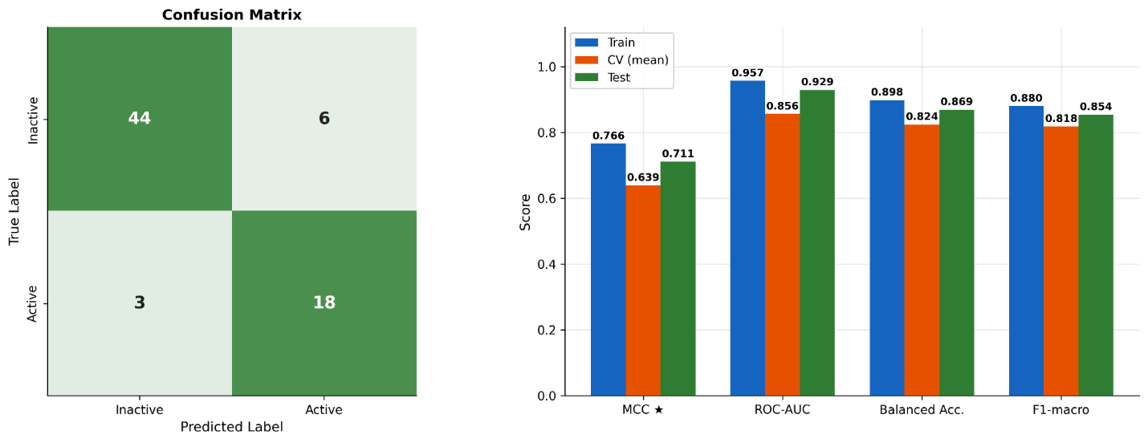
Figure 2. Performance of the Multispace SVM-RBF: The confusion matrix shows that the selected classifier correctly identified 88% of inactive compounds and 85.7% of active compounds in the test set, with 3 active molecules misclassified as inactive. MCC was used as the main selection metric. The test metrics are strong, including MCC = 0.711, ROC-AUC = 0.929, balanced accuracy = 0.869, and F1-macro = 0.854, indicating good generalization and supporting the use of this model for virtual screening.
Regression Training and Evaluation:
SVR-RBF combined with the full feature set achieved the highest Spearman correlation (CV rₛ = 0.674) and was selected for the final predictions. ElasticNet with descriptors-only representation had a slightly smaller train-CV difference (CV rₛ = 0.645, train-CV gap = 0.100). However, the performance of both models was very similar; the CV Spearman difference was only 0.029, and the train-CV gap difference was only 0.01, meaning either model would have been a valid choice.
Using SelectKBest, only 50 out of 1996 columns are selected, and the optimized hyperparameters were gamma = 0.01, epsilon = 0.05, and C = 1.
On the test set, the model achieved R² = 0.414, RMSE = 0.703 pChEMBL units, and MAE = 0.524 pChEMBL. Although the RMSE and MAE values appear relatively high, and R² is low, these metrics evaluate the accuracy of the predicted absolute pChEMBL values. In this study, the primary objective of the regression model is not to predict the exact potency value, but rather to rank candidate molecules. Therefore, ranking-based metrics provide a more relevant evaluation of the model’s objective. A Spearman rₛ = 0.647 and a pairwise accuracy = 0.74 indicate that the model correctly orders the relative potency of compound pairs (Figure 3). Moreover, most predictions showed residuals within ±1 unit; however, several compounds displayed larger residuals. This indicates that the model was more reliable for approximate compound ranking than for precise prediction of exact pChEMBL values (Figure 4).
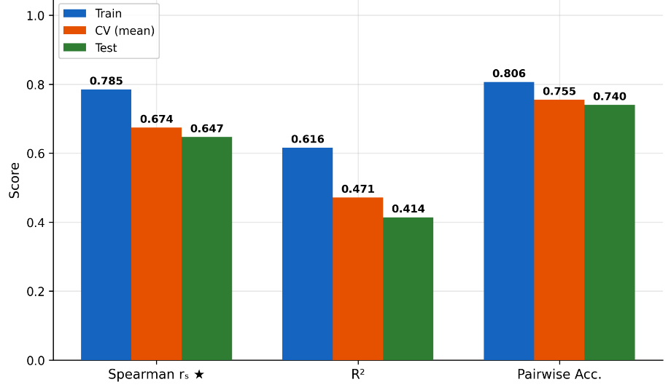
Figure 3. Performance of the full feature set with the SVR-RBF regression model. Training, cross-validation, and test results show an acceptable performance decrease on unseen compounds. The test ranking metrics remained acceptable, with rₛ = 0.647 and pairwise accuracy = 0.740, supporting the use of the model for candidate ranking. The lower R² = 0.414 indicates a weaker exact pChEMBL prediction, which was expected since the regression model was primarily used for prioritization rather than precise potency estimation.
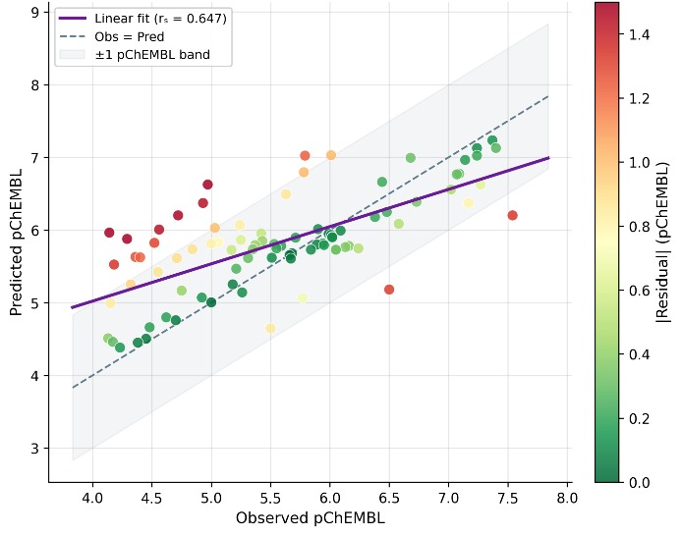

Figure 4. Observed versus predicted pChEMBL values plot of the full feature set with the SVR-RBF model: The model shows a moderate positive correlation between observed and predicted pChEMBL values (Spearman’s rₛ = 0.647). Although the predictions are concentrated in the middle range, with some overprediction of weaker compounds and underprediction of stronger compounds, most compounds fall within the ±1 pChEMBL band.

External Screening and Candidate Prioritization:
The selected classification (multispace SVM-RBF) and regression (full feature set SVR-RBF) models were applied to a prediction dataset of 1,991 approved ChEMBL compounds.
Applying the activity classifier at a primary relaxed screening threshold of 0.24, two compounds were classified as active: Elvitegravir (CHEMBL204656, predicted probability = 0.28, regression ranking score = 5.95) and Trelagliptin (CHEMBL1650443, predicted probability =0.25, regression ranking score = 5.16). We retained two compounds within a lower exploratory range (predicted probability is between 0.2 and 0.24) for regression prioritization (Figure 5).
The regression model was applied to all four prioritized candidates. The final ranking integrates activity probability and regression score as the primary and secondary ordering criterion, respectively. Applicability-domain analysis showed that none of the ranked candidates fell within the applicability domain of either the classification or regression model. Therefore, these candidates should be interpreted as exploratory repurposing hits, and further validation through docking and experimental testing is required.
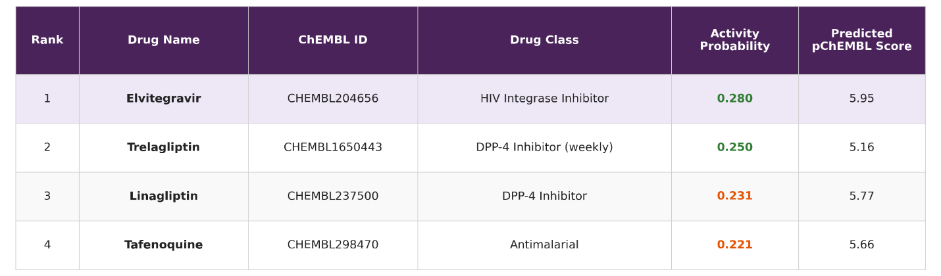Figure 5. Prioritized external screening candidates with classification probabilities and regression-based ranking scores. Elvitegravir and Trelagliptin were the only candidates classified as active compounds using the relaxed activity threshold, while Linagliptin and Tafenoquine were retained as exploratory near-threshold candidates. Final prioritization was based primarily on activity probability and secondarily on the predicted pChEMBL score, explaining why Linagliptin and Tafenoquine had a higher regression score than Trelagliptin but a lower final rank.

Ensemble Cross docking and Redocking:
Job Completion and Definition of the Refined Validation Set:
Across the two-receptor ensemble, 1,572 docking jobs were run in total. This represented 786 unique crystallographic Mac1 ligands, each docked against the two receptor conformations, 5SOP and 5SRY. Overall job completion was high: 1,548 jobs completed successfully, corresponding to a completion rate of 98.5%, while 24 jobs failed because of ligand-preparation errors, mainly incomplete bond information in the source mmCIF or Chemical Component Dictionary entries.
Although most jobs were completed successfully, RMSD-based validation could only be performed when a readable crystallographic reference ligand was available. RMSD values were therefore computable for 1,036 of the 1,572 jobs, while the remaining 536 jobs were not RMSD-evaluable because no suitable reference SDF could be read. These unevaluable cases were most associated with ligands prepared from CCD idealised coordinates, where no experimentally observed three-dimensional ligand instance was available for direct comparison.
The 1,036 RMSD-evaluable jobs were then classified according to their relationship to the canonical Mac1 active site. Most evaluable jobs, 882 in total, were classified as strict canonical active-site binders with RMSD values below 5 Å. A further 74 jobs had RMSD values between 5 and 10 Å and were retained as borderline cases. The remaining 80 jobs had ensemble best RMSD values above 10 Å and were classified as off-site binders, indicating that their crystallographic reference positions lay outside the docking region.
For the final validation analysis, results were grouped by ligand rather than by individual docking job, since each compound had been docked against both receptor structures. This produced 518 unique ligands with at least one usable RMSD result. Of these, 40 ligands were excluded as off-site binders, leaving 478 ligands in the refined canonical active-site validation set. This refined set included 37 borderline ligands, which were retained in the analysis but flagged for caution.

Pose Recovery and the Sampling–Scoring Gap:
Pose recovery was evaluated using heavy-atom RMSD between the docked pose and the crystallographic reference position. The primary success threshold was set at 2.0 Å, with 3.0 Å as a secondary more permissive threshold (Cole et al., 2005; Warren et al., 2006; Wierbowski et al., 2020). On the refined active-site job set, the best pose among the top 20 Vina outputs achieved a success rate of 46.2% at 2.0 Å and 69.7% at 3.0 Å. In contrast, the top-ranked Vina pose alone recovered the crystallographic pose in only 12.4% of jobs at 2.0 Å and 20.5% at 3.0 Å.
This difference shows a clear sampling–scoring gap. Near-native poses were often present within the top 20 docking outputs, but they were not consistently ranked first by Vina (Cole et al., 2005; Warren et al., 2006; Trott & Olson, 2010). Figure 6 illustrates this pattern, the best-of-20 curve rises much more rapidly than the top-1 curve, showing that pose generation was substantially more successful than pose ranking.
At the ligand level, where a ligand was counted as successful if either receptor recovered a near-native pose, the ensemble performed better. The combined 5SOP/5SRY ensemble recovered 261 of 478 ligands within 2.0 Å, giving a success rate of 54.6%. At the 3.0 Å threshold, this increased to 360 of 478 ligands, or 75.3%. These results indicate that the ensemble provides useful pose-generation performance, although the top-ranked Vina pose alone is not sufficiently reliable for final pose selection.
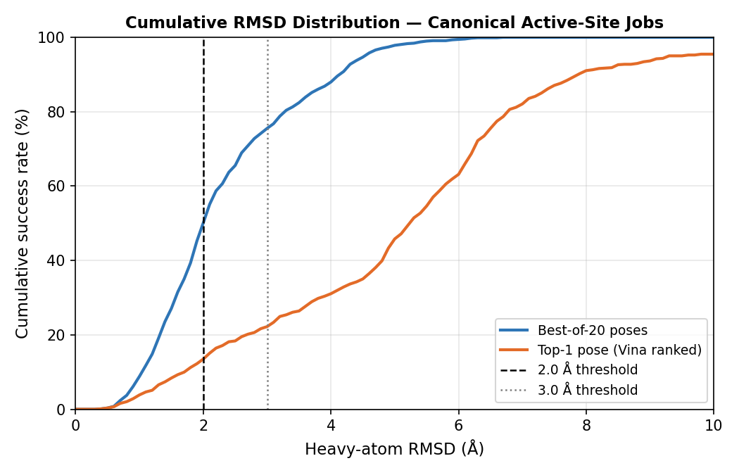

Figure 6. Cumulative RMSD distribution for refined canonical active-site jobs. The best-of-20 curve rises more rapidly than the top-1 curve, showing that Vina frequently sampled near-native poses but did not consistently rank them first.

Per-Receptor Performance and Ensemble Rescue:
The two receptor conformations showed similar individual performance. For the refined active-site set, 5SOP recovered 224 of 478 ligands within 2.0 Å, corresponding to a best-of-20 success rate of 46.9%. 5SRY recovered 218 of 478 ligands, giving a comparable success rate of 45.6%. At the 3.0 Å threshold, both receptor structures reached 69.7%. Top-1 success remained low for both receptors, at 13.2% for 5SOP and 11.7% for 5SRY.
These results show that neither receptor conformation was clearly superior when used alone. However, combining the two structures improved overall recovery. The ensemble achieved a best-of-20 ligand-level success rate of 54.6% at 2.0 Å, exceeding the performance of both 5SOP alone and 5SRY alone.
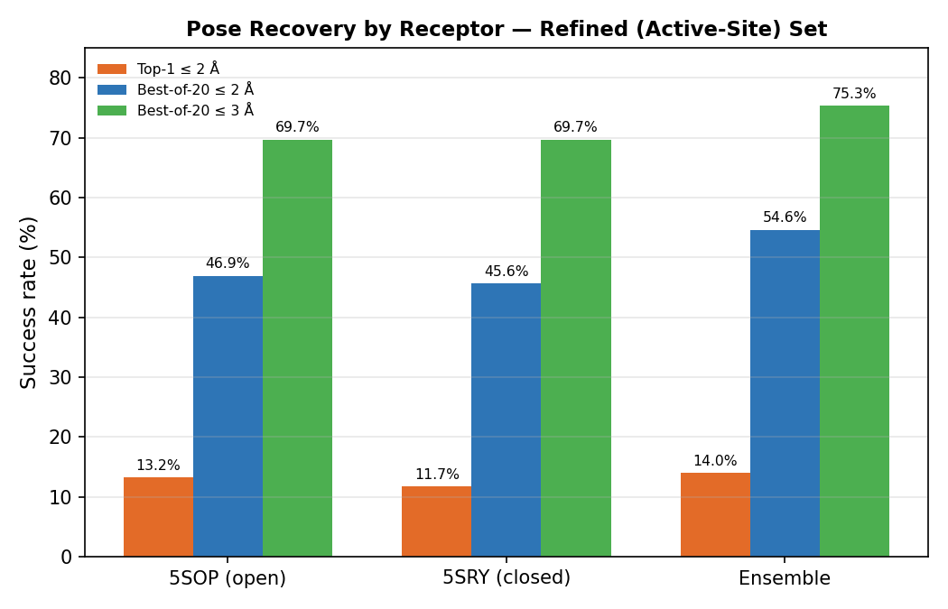

Figure 7. Pose-recovery success rates for 5SOP, 5SRY, and the combined ensemble on the refined active-site set. Both individual receptors performed similarly, while the ensemble gave the highest success rate at the 2.0 Å threshold.

The improvement from ensemble docking was driven by receptor-specific rescue. Of the 478 ligands in the refined validation set, 261 were recovered within 2.0 Å by at least one receptor. Within this recovered group, 181 ligands were successful in both receptor structures, while 43 ligands were recovered only by 5SOP and 37 ligands only by 5SRY. Thus, both receptor conformations contributed to unique successful cases that would have been missed by the other structure alone. This supports the use of the 5SOP/5SRY ensemble rather than a single-receptor docking protocol.

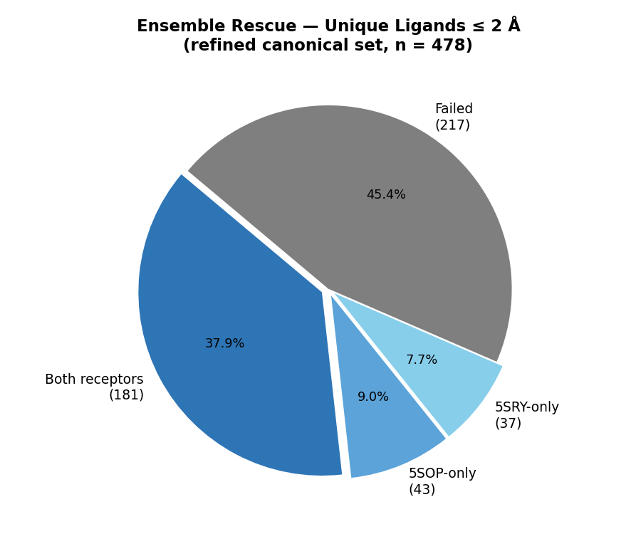

Figure 8. Ensemble rescue across the refined canonical active-site set. The 5SOP-only and 5SRY-only fractions show that each receptor conformation recovered ligands missed by the other, supporting the use of the two-receptor ensemble.
Overall Validation Outcome:
Overall, the 5SOP/5SRY ensemble passed the main validation criteria for pose generation against the SARS-CoV-2 Mac1 active site. The refined ligand-level best-of-20 success rate reached 54.6% at 2.0 Å, exceeding the predefined 50% threshold for good performance. The ensemble also improved recovery over either receptor alone and showed clear receptor-specific rescue between the open and closed conformations.

Limitations and Future Directions
Several limitations should be considered when interpreting the results of this study. First, the QSAR models were trained on a relatively small and assay-specific dataset from ChEMBL. Although the dataset was carefully cleaned and scaffold splitting used to reduce structural leakage, the number of active compounds remained limited. This may impact the ability of the models in generalizing to chemically distinct approved drugs.
Second, the regression model showed moderate ranking performance but weaker exact pChEMBL prediction. This indicates that the model is more appropriate for prioritizing compounds than for estimating precise potency values. The predictions should therefore be considered as relative ranking scores rather than direct experimental activity estimates.
Another important limitation is the applicability-domain result. None of the four prioritized approved compounds fell under the classification or regression applicability domains. This does not mean that the compounds are inactive, however it shows that they are chemically distant from the training data. Therefore, Elvitegravir, Trelagliptin, Linagliptin, and Tafenoquine should be treated as exploratory repurposing candidates rather than confirmed computational hits.
The docking component also possesses limitations. The validation showed that the 5SOP/5SRY ensemble can generate near-native poses, but the top-ranked Vina pose was often not the most accurate one. This sampling-scoring gap indicates that docking results should not be interpreted using the first-ranked pose alone. Furthermore, receptor flexibility was represented using only two crystal structures, which may not fully capture the conformational range of the Mac1 binding pocket. Ligand protonation, tautomeric state, and reference-ligand quality may also affect docking and RMSD evaluation.
Future projects should dock the prioritized QSAR candidates against both validated Mac1 conformations and compare their binding poses, interactions, and docking scores. Additional rescoring, molecular dynamics simulations, or free-energy calculations could improve confidence in pose selection. Finally, the most promising compounds should be tested experimentally to confirm whether they bind to or inhibit SARS-CoV-2 Mac1.

Conclusion
This study developed a computational drug-repurposing workflow specifically targeting the SARS-CoV-2 Mac1 domain by combining QSAR machine learning with ensemble docking validation. The classification model performed well in distinguishing active from inactive compounds, while the regression model provided a useful ranking tool for prioritizing candidates according to predicted potency.
Screening of approved ChEMBL compounds identified Elvitegravir and Trelagliptin as predicted active candidates, with Linagliptin and Tafenoquine retained as exploratory near-threshold compounds. However, because all four candidates were outside the models’ applicability domains, they should be interpreted as preliminary hits that require further computational and experimental validation.
The docking validation supported the use of a two-receptor Mac1 ensemble. The combined 5SOP/5SRY protocol recovered 54.6% of refined active-site ligands within 2.0 Å and 75.3% within 3.0 Å, outperforming either receptor alone. At the same time, the low top-ranked pose recovery showed that Vina scoring alone is not reliable enough for final pose selection.
Overall, the results suggest that the proposed workflow is useful for early-stage Mac1 inhibitor prioritization. Its strongest value is in filtering and ranking candidate compounds, followed by structure-based evaluation using a validated docking ensemble. Further docking of the prioritized candidates, rescoring, and experimental testing will be needed before any compound can be considered a reliable Mac1 inhibitor candidate.
External screening identified Elvitegravir and Trelagliptin as predicted active candidates, with Linagliptin and Tafenoquine retained as near-threshold exploration hits. However, because these candidates were outside the models’ applicability domains, they should be considered preliminary and require further validation. As a next step, the predicted compounds should be docked against the validated Mac1 structures, 5SOP and 5SRY, to assess their binding poses and compare their interactions across both receptor conformations.

References
Esposito, C., Landrum, G. A., Schneider, N., Stiefl, N., & Riniker, S. (2021). GHOST: Adjusting the decision threshold to handle imbalanced data in machine learning. Journal of Chemical Information and Modeling, 61(6), 2623–2640. https://doi.org/10.1021/acs.jcim.1c00160
Cole, J. C., Murray, C. W., Nissink, J. W. M., Taylor, R. D., Taylor, R. D., Taylor, R., & Taylor, R. (2005). Comparing protein–ligand docking programs is difficult. Proteins Structure Function and Bioinformatics, 60(3), 325–332. https://doi.org/10.1002/prot.20497
Trott, O., & Olson, A. J. (2009). AutoDock Vina: Improving the speed and accuracy of docking with a new scoring function, efficient optimization, and multithreading. Journal of Computational Chemistry, 31(2), 455–461. https://doi.org/10.1002/jcc.21334
Frick, D. N., Virdi, R. S., Vuksanovic, N., Dahal, N., & Silvaggi, N. R. (2020). Molecular basis for ADP-ribose binding to the Mac1 domain of SARS-CoV-2 nsp3. Biochemistry, 59(28), 2608–2615. https://doi.org/10.1021/acs.biochem.0c00309
Gahbauer, S., Correy, G. J., Schuller, M., Ferla, M. P., Doruk, Y. U., Rachman, M., Wu, T., Diolaiti, M., Wang, S., Neitz, R. J., Fearon, D., Radchenko, D. S., Moroz, Y. S., Irwin, J. J., Renslo, A. R., Taylor, J. C., Gestwicki, J. E., von Delft, F., Ashworth, A., ... Fraser, J. S. (2023). Iterative computational design and crystallographic screening identifies potent inhibitors targeting the Nsp3 macrodomain of SARS-CoV-2. Proceedings of the National Academy of Sciences, 120(2), Article e2212931120. https://doi.org/10.1073/pnas.2212931120
Guo, Q., Hernandez-Hernandez, S., & Ballester, P. J. (2025). UMAP-based clustering split for rigorous evaluation of AI models for virtual screening on cancer cell lines. Journal of Cheminformatics, 17, Article 94. https://doi.org/10.1186/s13321-025-01039-8
Hoch, N. C. (2021). Host ADP-ribosylation and the SARS-CoV-2 macrodomain. Biochemical Society Transactions, 49(4), 1711–1721. https://doi.org/10.1042/BST20201212
Li, J., Luo, D., Wen, T., Liu, Q., & Mo, Z. (2021). Representative feature selection of molecular descriptors in QSAR modeling. Journal of Molecular Structure, 1244, Article 131249. https://doi.org/10.1016/j.molstruc.2021.131249
National Center for Biotechnology Information. (n.d.). BLAST: Basic Local Alignment Search Tool. National Library of Medicine. Retrieved May 1, 2026, from https://blast.ncbi.nlm.nih.gov/Blast.cgi
National Institutes of Health. (n.d.). National Institutes of Health (NIH). U.S. Department of Health and Human Services. Retrieved May 1, 2026, from https://www.nih.gov/
Orosz, Á., Héberger, K., & Rácz, A. (2022). Comparison of descriptor- and fingerprint sets in machine learning models for ADME-Tox targets. Frontiers in Chemistry, 10, Article 852893. https://doi.org/10.3389/fchem.2022.852893
RCSB Protein Data Bank. (n.d.). RCSB PDB: Homepage. Retrieved May 1, 2026, from https://www.rcsb.org/
Resource for Biocomputing, Visualization, and Informatics. (n.d.). UCSF ChimeraX. University of California, San Francisco. Retrieved May 1, 2026, from https://chimerax.ucsf.edu/
The Scripps Research Institute. (n.d.). AutoDock Vina. Retrieved May 1, 2026, from https://vina.scripps.edu/
Warren, G. L., Andrews, C. W., Capelli, A., Clarke, B., LaLonde, J., Lambert, M. H., Lindvall, M., Nevins, N., Semus, S. F., Senger, S., Tedesco, G., Wall, I. D., Woolven, J. M., Peishoff, C. E., & Head, M. S. (2005). A critical assessment of docking programs and scoring functions. Journal of Medicinal Chemistry, 49(20), 5912–5931. https://doi.org/10.1021/jm050362n
Westbrook, J. D., Shao, C., Feng, Z., Zhuravleva, M., Velankar, S., & Young, J. (2015). The chemical component dictionary: Complete descriptions of constituent molecules in experimentally determined 3D macromolecules in the Protein Data Bank. Bioinformatics, 31(8), 1274–1278. https://doi.org/10.1093/bioinformatics/btu789
Wierbowski, S. D., Wingert, B. M., Zheng, J., & Camacho, C. J. (2019). Cross‐docking benchmark for automated pose and ranking prediction of ligand binding. Protein Science, 29(1), 298–305. https://doi.org/10.1002/pro.3784
Zakharov, A. V., Peach, M. L., Sitzmann, M., & Nicklaus, M. C. (2014). QSAR modeling of imbalanced high-throughput screening data in PubChem. Journal of Chemical Information and Modeling, 54(3), 705–712. https://doi.org/10.1021/ci400737s

